At our school we installed a weather station. With this we have been collecting the weather data. Below is some of the data represented using charts generated by the weather station. It allows us in our school to compare the weather from last year and this year.

Our Weather Station is a professional ‘Smart Weather’ Unit Model WH2080. It is set up on the school roof and our caretaker/site manager looks after the control unit in his office.

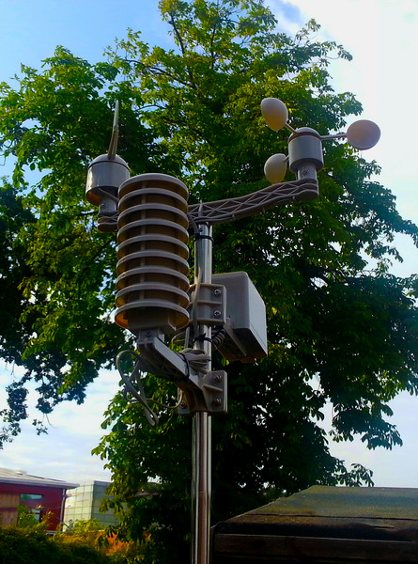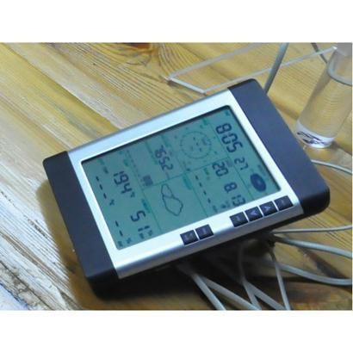

This weather station measures wind speed, wind direction, temperature and humidity (both inside and outside), rainfall and barometric pressure.

The weather station’s console displays a wide range of parameters in an easy-to-read format on a large LCD.

**YEARLY TRENDS 2012/13**

**Matchborough Redditch: WEATHER AVERAGES & EXTREMES**

The following charts show yearly weather trends with information on monthly weather averages and extremes. This information was obtained from data supplied from our Weather Station Smart Box Console. We used a Weather Station Program called ‘WeatherLink’ which analyses the data from our weather station and then plots graphs for us.

**Temperature**

**The chart below plots the average high and low temperature for each month of the year. It also shows the maximum and minimum recorded temperatures.**



**Precipitation Amount**

**The chart below plots the average percentage monthly precipitation amount.**

**This is the data below:**

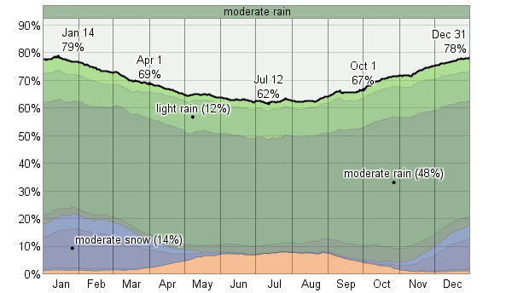

A breakdown of Types of Precipitation throughout the Year

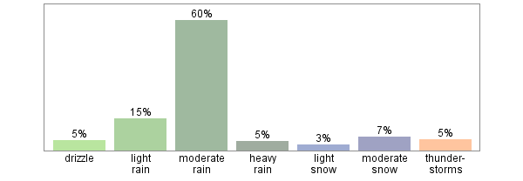

**Snow days**

**The chart below plots the number of days in any month that snow fell a year ago.**



**Wind Speed**

**The chart below plots the average daily wind speed for any month recorded. It also shows the maximum recorded sustained wind speed for each month.**

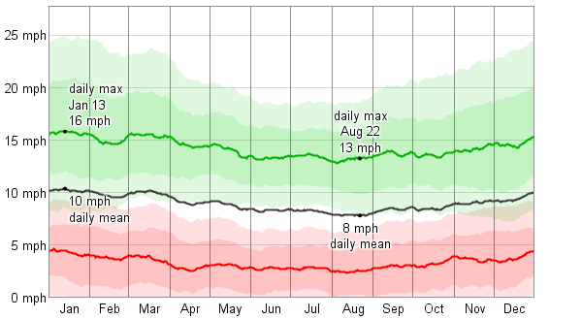

Analysis

We have only had our weather station for several months.

Our data shows that 2012/2013 there was extremes in temperature.

The winter was very cold with lots of snow events. The Kingfisher school was closed on heavy snow dates. Due to cold clear nights we also had several days of very icy and slippery roads which meant that the pupils were late in arriving to school. At times transport was cancelled due to the serious risks of potential accidents as well as accidents during the morning rush hour.

The summer had above average temperatures than the average expected and we had a heat wave with lots of sunshine last summer

The latest data for this winter so far this year shows that our winter has been very mild, there have been no snow events as yet and frosty mornings and icy conditions have been rare and fare between.

It’s not known if it is due to global human interference or just due to cyclic events of weather changes which can occur from year to year. Although weather climate data suggests those extremes in weather and a general warming in condition may be due to human influences on the environment although the evidence is not concrete at all.

**As it stands so far in the UK:**

**Based on the Met Office’s modern data set which started in 1910, December was the eighth mildest on record across the UK, and the mildest since 1988.**

**The warmth also shows up in Central England Temperature (CET) data, with December ranked 33rd in 356 years of data.**

**January is so far even more impressive, currently standing at 17th warmest since 1659 in the CET record as we head into the last third of the month.**

**But before we write off winter completely, it is often forgotten that February is statistically the coldest month of the year, and one of the driest.**

**Indeed in many eastern areas the second half of February is the driest period of the year.**

**This reminds us that the jet stream, which is normally at its most powerful during the first half of winter, often weakens in February increasing the risk of our weather being influenced by colder air from the north or the east, associated with higher pressure.**

**Mild wet winter continues in early January figures**

**16012014**

**Provisional half-month statistics up to the 15th of January show a continuation of the generally mild and wet theme of the UK’s winter thus far.**

**The mean UK temperature up to the 15th of January is 5.1 °C, which is 1.5 °C above the long-term (1981-2010) average.**

**The mild January so far follows on from a mild UK December, which had a mean temperature of 5.7 °C, which is 1.8 °C above the long-term average – making it the eighth mildest December in records dating back to 1910, and the mildest since 1988.**

**It’s a similar story with UK rainfall. We’d normally expect about 48% of the January average rainfall by the 15th of the month, but the UK has seen 87.9mm so far – which equates to 72% of the January average.**

**As usual, there are regional varations. England has been particularly wet so far this month, having already seen close to its full-month average, and Wales is not too far behind. Scotland and Northern Ireland, however, are closer to the ‘normal’ amount of rain we’d expect at this stage.**

**The wet January so far once again follows the theme set in December, which saw 184.7mm of rain – which is 154% of the average for the month.**

**While this means January, and winter, so far have been mild and wet, it doesn’t mean they will finish that way. We often see half-month or half-season figures which then change dramatically by the end of the period. So the message is, it’s too early to judge how January 2014 or winter 2013/4 will finish up.**

**The main reason for the mild and wet weather so far is that we have seen a predominance of west and south-west winds, bringing in mild air from the Atlantic – as well as generally unsettled conditions.**

**The table below shows provisional figures from 1-15 of January, with actual figures so far compared to full-month averages. We would normally expect rainfall and sunshine to be about 48% of the full-month average at this stage.**

|  |  |  |  |  |  |
| --- | --- | --- | --- | --- | --- |
| **Mean Temperature** | | **Sunshine hours** | | **Rainfall** |  |
| **January 1-15** | **Actual** | **Diff from Avg** | **Actual** | **% of Avg** | **Actual** | **% of Avg** |
|  | **degC** | **degC** | **hours** | **%** | **mm** | **%** |
| **UK** | 5.1 | 1.5 | 26.1 | 55 | 87.9 | 72 |
| **England** | 6.0 | 1.9 | 34.7 | 64 | 80.4 | 97 |
| **Wales** | 5.8 | 1.7 | 20.6 | 42 | 137.7 | 88 |
| **Scotland** | 3.6 | 1.0 | 15.4 | 43 | 91.2 | 51 |
| **N Ireland** | 4.4 | 0.2 | 14.6 | 33 | 62.8 | 54 |

**Our weather station shows for our area here in the West Midlands that indeed this is the case. Apart from several storms at Christmas 2014 it has indeed been very mild**