As part of the Comenius Eco – Warrior project. We, at the Kingfisher school, decided to look at our own CARBON FOOTPRINTS.

What is a Carbon Footprint?

The term “carbon footprint” refers to the amount of carbon (C02) we emit individually in any one-year period. C02 is produced from many sources and is the primary gas responsible for Global warming and the resulting alarming changes in our climate.



**What do we mean by carbon?**

When people talk about carbon emissions and carbon footprints, they usually mean **carbon dioxide (CO2) emissions**.

Carbon dioxide is released when we burn carbon-based fuels. Almost all fuels are carbon-based, including:

* **petrol and diesel** in our cars
* **gas, oil and coal** in our homes and power stations
* **jet fuel** in aeroplanes.

Carbon dioxide is a greenhouse gas - it traps the sun's heat and keeps the earth warm. Too much CO2 in the air leads to climate change, also known as global warming.

Other greenhouse gases, such as methane, also contribute to climate change. Countries and organisations count these as part of their carbon emissions. But for individuals the most important carbon emission is carbon dioxide.

Some Science about Carbon Emissions:

Carbon dioxide is a greenhouse gas - it traps the sun's heat and keeps the earth warm. Too much CO2 in the air leads to climate change, also known as global warming.

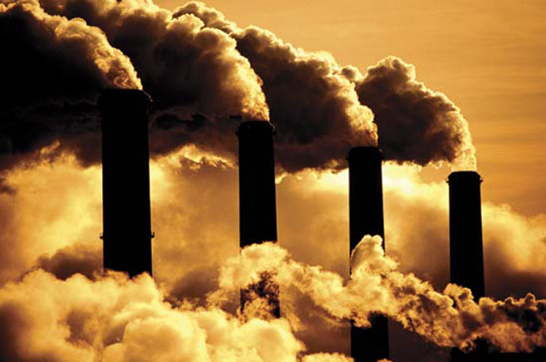

Other greenhouse gases, such as methane, also contribute to climate change. Countries and organisations count these as part of their carbon emissions. But for individuals the most important carbon emission is carbon dioxide.

What is a carbon footprint?

Your carbon footprint is the amount of carbon dioxide that enters the atmosphere because of the electricity and fuel you use. It's measured in tonnes of carbon dioxide.

Your carbon footprint mostly depends on:

* how much energy you use to **heat your home**
* the **electronics and appliances** you use
* what kind of **transport** you use day-to-day
* how often you **fly.**

Some students in Year 11 decided to try to find out how much carbon footprints they personally produced.

There are many sites on the internet where you can carry out a survey to see how much Carbon is produced by individuals and organisations. We call these sites “ Carbon Footprint Calculator sites:

Here are some examples of sites that can be used to calculate a carbon footprint:

[***http://www.forestcredits.org.uk/***](http://www.forestcredits.org.uk/)

[***http://www.conservation.org/act/live_green/carboncalc/Pages/default.aspx?gclid=CLuwv83ykbwCFfMftAodBQIAJw***](http://www.conservation.org/act/live_green/carboncalc/Pages/default.aspx?gclid=CLuwv83ykbwCFfMftAodBQIAJw)

[***http://footprint.wwf.org.uk/***](http://footprint.wwf.org.uk/)

We looked at various Carbon Footprint calculators to see which ones would be the best to use. Some of the Calculators are ever too simple or too long and complicated to use. But we settled for using the following as we thought it was the best because it was easy to understand and use:

<http://footprint.wwf.org.uk/questionnaires/show>

Some of the pupils in year 11 undertook the activity and it only took on average of 5 minutes only to complete the survey.

Here are some of the questions asked in the survey that we undertook on the WWF site:

**FOOD**

## 1. How would you best describe your diet?

* Meat and/or fish eater



* Vegetarian



* Vegan



## 2. How often do you eat meat or fish?

* More than once a day



* Once a day



* Few times a week



* Once a week



* Less than once a week



## 3. How often do you buy/eat organic meat, vegetables or dairy products?

* Always



* Often



* Sometimes



* Never



## 4. How often do you buy locally produced meat, vegetables or dairy products?

* Always



* Often



* Sometimes



* Never



**TRAVEL**

## 1. Which of these vehicles do you use most often?

* Car



* Motorbike



* Neither



## 2. Which of these best describes the car you use most often?

* Small diesel car



up to 1.5L engine

* Small petrol car



up to 1.5L engine

* Medium diesel car



1.6-1.8L engine

* Medium petrol car



1.6-1.8L engine

* Large diesel car



1.9L or above

* Large petrol car



1.9L or above

## 3. How many hours a week do you spend in cars or on motorbikes (personal use or commuting)?

* Under 2 hours



* 2 to 5 hours



* 5 to 15 hours



* 15 to 25 hours



* Over 25 hours



## 4. How long do you spend on the train each week (personal use or commuting)?

* I don't travel by train



* Under 2 hours



* 2 to 5 hours



* 5 to 15 hours



* 15 to 25 hours



* Over 25 hours



## 5. How long do you spend on the bus each week (personal use or commuting)?

* I don't travel by bus



* Under 1 hour



* 1 to 3 hours



* 3 to 6 hours



* 6 to 10 hours



* Over 10 hours



## 6. In the last year, how many return flights have you made in the following locations?

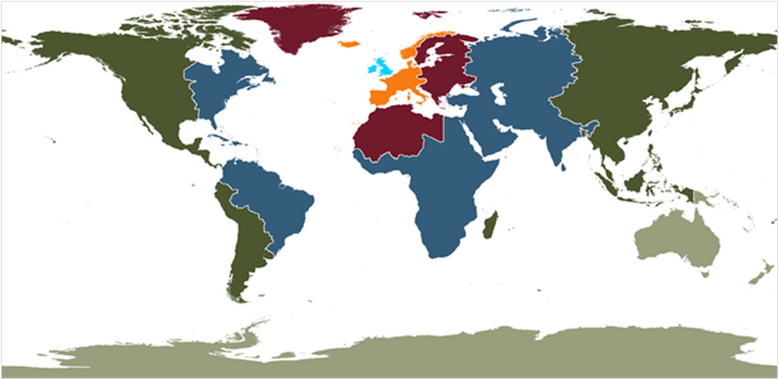

* Zone 1



* Zone 2



* Zone 3



* Zone 4



* Zone 5



* Zone 6



**YOUR HOME**

## 1. How would you describe your home?

* Detached



* Semi detached



* Terrace



* Flat



## 2. How many people (aged 17 and over) live in your house?

* 1



* 2



* 3



* 4



* 5 or more



## 3. How do you heat your home?

* Gas



* Oil



* Electricity



* Wood



## 4. Do you regularly turn off lights and appliances?

* Yes



* No



## 5. What temperature is your home?

* 11-14°C



Cold

* 14-17°C



Cool

* 18-21°C



Warm

* Over 22°C



Hot

## 6. Which of these energy efficiency improvements have been installed in your home?

Tick all the relevant options then press "next"



* Energy saving light bulbs



* Loft insulation



* Cavity wall insulation



* Condensing boiler



* Double glazing



**OTHER STUFF**

## 1. In the last 12 months, have you bought any of these new household items?

Tick all the relevant options then press "next"



* TV or Hi-fi



* Large item of furniture



* Washing machine, dishwasher, tumble dryer or fridge freezer



* MP3 player, mobile phone or camera



## 2. If you have any pets, how much did you spend on their food, vet bills, kennels, etc in the last 12 months?

* I don't have a pet



* £0 - 100



* £100 - 300



* £300 +



## 3. How much did you spend on new jewellery in the last year?

* £0



* £1 - 50



* £50 - 150



* £150 +



## 4. How much did you spend on powered DIY tools and equipment in the last 12 months?

* £0



* £1 - 25



* £25 - 100



* £100 +



## 5. How much did you spend on bath and grooming products in the last 12 months?

* £0 - 100



* £100 - 300



* £300 +



## 6. Which of these types of waste do you recycle and/or compost?

Tick all the relevant options then press "next"



* Food



* Paper



* Tin cans



* Plastic



* Glass



**Some really interesting Survey results !!!**

Our Science teacher took the Carbon Footprint Calculator survey and this was his results:

**Your Carbon footprint**

4.18planets

We would need **4.18** planets if everyone lived your lifestyle.

We only have one.

## About your score

* 1.1 higher than the UK average of 3 planets
* The equivalent of 27.1 carbon tonnes

Your footprint is roughly how many planets we would need if everyone lived your lifestyle. A lower score is better.

Some of our Year 11 results:

JODY:

## About your score

**Your Carbon footprint**

4.47 planets

We would need **4.47** planets if everyone lived your lifestyle.

**We would need 4.47 planets if everyone lived your lifestyle.**

**We only have one.**

* 1.4 higher than the UK average of 3 planets
* The equivalent of 27.7 carbon tonnes. Your footprint is roughly how many planets we would need if everyone lived your lifestyle. A lower score is better.

**JASON**

About your score

**Your Carbon footprint**

1.51planets

We would need **1.51** planets if everyone lived your lifestyle.

We only have one.

* 1.6 lower than the UK average of 3 planets
* The equivalent of 9.1 carbon tonnes. Your footprint is roughly how many planets we would need if everyone lived your lifestyle. A lower score is better.

**What can clearly be seen by the above results is that we need to take more care and think carefully how we waste energy.**

**We should think of ways of losing less energy and also recycling more.**

**Basically USING LESS ENERGY ---------🡪LESS CARBON FOOTPRINT**

**and therefore less Global warming ☺☺☺**

**Here are some Practical steps we can take to reduce our Carbon footprint:**

## Reduce Your Carbon Footprint

1. **Turn down your thermostat. Turning your thermostat down by one degree centigrade could save a typical home £49 a year.**
2. **Close and/or line your curtains to keep in warmth. Setting your heating to turn off one hour before you leave the house and come on half an hour before you get home could save you £51 a year.**
3. **Turn off lights. Switching off four unnecessary lightbulbs and you could save £32 a year.**
4. **Turn off standby. Leaving your TV and all accessories attached to it on standby all the time could cost you £46 a year.**
5. **Turn down and use the half load setting on washing machines and tumble dryers. Washing laundry at 40 to 60 degrees centigrade in your washing machine could save you £12 a year.**
6. **Don’t boil more water in the kettle than you need to. If you always boil the amount of water needed for one cup rather than boiling a full kettle, you could save £30 a year.**
7. **Fix leaks as these are not only wasting water but also energy if they’re from a hot water source.**
8. **Use energy saving lightbulbs to save even more money and energy.**
9. **Recycle more!**
10. **Fly less. Train travel is up to 10 x more energy efficient than plane travel. Of course, not travelling at all is even more effective…**