Comenius – Write Up:
2013/14 Environmental Hazards and Conclusions
Year 10a Science – Class collaboration report
The Kingfisher School
UK Winter Storms 2012/13
UK's worst winter storms for two decades.
All over the UK this winter we have had lots of winter storms and lots of flooding.
This has been especially true in the Midlands where the Kingfisher school is located.
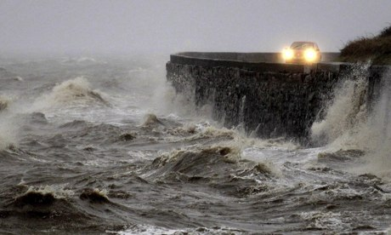It has been very bad for us because we have many rivers and streams in the area which easilyflood.

Pupils who come to the school travel huge distances and many come in to school using taxis.
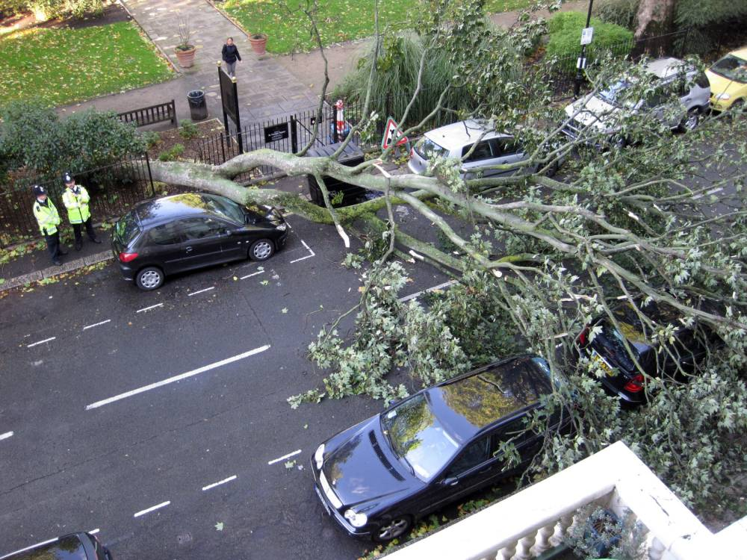Sometimes pupils have not been able to get into school because of flooding so they have missed their education. Also we have had very dangerous winds. Which have been very strong.
Trees have collapsed and blocked pupil’s access to school in the morning.
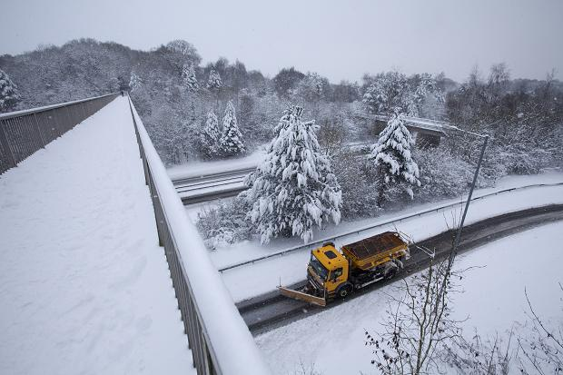
SNOW Blizzards:
Last winter we also head heavy snow fall and blizzards in January. There was a lot of disruption throughout the UK and especially in the Midlands where the Kingfisher school is located. The school had to close for a few days because transportsuchas taxis and cars could not travel due to the dangerous conditions. Snow and blizzard conditions blanketed the whole of the country this time last year and caused havoc all over.
A Road near our school during the storms
Transport links were severely hampered with flights grounded and trains and cars also extensively affected.
HOT SUMMER 2013:
Here in the UK last summer was the warmest driest and hottest since 1996.
It meantin Britain we had many day of 30C-plus temperatures - the first prolonged heat wave" since 2006.
It was the longest period of hot weather since 2006, with prolonged temperatures above the average for the time of year.
Normally we can expect it to reach 20-22C (68-71.6F) in England and Wales.

Conclusion:
Why are we having so many weather extremes in the UK?
It is usual to have years when the weather can be abnormal but here at the Kingfisher school we think that over the past few years there have been too many weather extremes and we think that this is not normal..
What do the Climate/weather experts say?
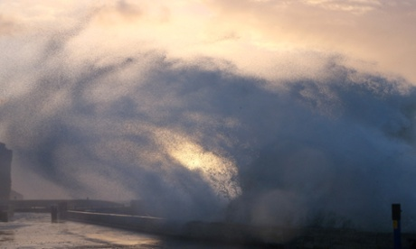Lingering warm air that drifted from the Sahara to the Atlantic this summer could be to blame for Britain's storms and heavy snowfall in the US and Canada
A wave breaks over the seafront at dawn in West Bay during stormy weather on 3 January in Dorset
It started with the St Jude’s Day storm on 28 October, and most recently we’ve seen Christian, Dirk, and Erich storms slamming our shores Over the festive season and Christmas.

Between them these winter storms have brought misery to huge swathes of the UK, flooding hundreds of homes, cutting the power to thousands and bringing much of the transport system to a halt. But how unusual is this weather and what is behind it all?
What do we think at the Kingfisher school?
We agree that human influence and Global warming is a major cause of the problems we are having with the weather extremes we are experiencing in Europe and the UK.

We agree on a UN report recently published which states:
A landmark report says scientists are 95% certain that humans are the "dominant cause" of global warming since the 1950s.
The report by the UN's climate panel details the physical evidence behind climate change.
On the ground, in the air, in the oceans, global warming is "unequivocal", it explained.
It adds that a pause in warming over the past 15 years is too short to reflect long-term trends.
The panel warns that continued emissions of greenhouse gases will cause further warming and changes in all aspects of the climate system.
To contain these changes will require "substantial and sustained reductions of greenhouse gas emissions".

So basically, we the younger generation need to take care of our climate by being more eco-friendly and taking care with what we do and how we do it…

HOW?

- Recycle more
- Use clean alternative fuels such as solar and wind power.
- Use transportation less and if we have to share cars to reduce Carbon dioxide levels.

If we don’t we will face an ever increasing level of worse and extreme weather episodes which will affect our lives and society even more than it does today.

